What you should know before your first balloon flight!
An hour in a free balloon ist like a day's holiday
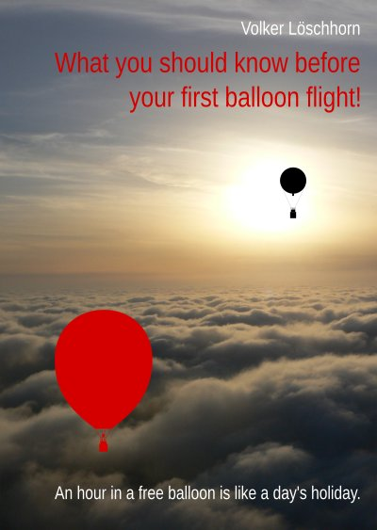Title of the book What you should know before your first balloon flight! by Volker Löschhorn
www.epubli.com
The first human balloon flight in 1783 was a dream come true for mankind. Would taking part in a balloon flight be the fulfilment of a dream for you too? Then don't hesitate, today there are many ways in which you can fulfil this dream.
But to make your balloon trip a great experience, I have put together some information for you here to help you prepare for your balloon flight.

Balloon classes
Hot Air Balloon - Gas Balloon - Hot Air Airship
There are different classes of balloons. I present them to you here:

Hot air balloon
hot air balloon graphic
Today, you usually see hot air balloons in the sky. This was not always the case. Although the first balloon was also a hot-air balloon, these early flights were literally a fire hazard. There were no non-flammable materials for the balloon envelopes, nor was there any way of heating the air without flying sparks. So the hot air balloon quickly sank into a deep sleep. This only changed in the 1960s when the modern hot-air balloon with a non-flammable envelope made of synthetic materials and a propane burner was developed in the USA. And this modern hot-air balloon then spread more and more rapidly around the world.
Today, hot air balloons of various shapes and sizes are used for sports, passenger flights and advertising.

Gas balloon
Gas balloon graphic
Just a few days after the launch of the first hot air balloon, the first gas balloon using hydrogen as the lifting gas also took off. It dominated ballooning for almost two centuries. With it, ballooning experienced its first boom when Charles Green discovered that the widely used illuminating gas could also be used as a lifting gas. And there was a gasworks in almost every large town at the time, making it possible to fill and launch a gas balloon. With the introduction of natural gas, which was too heavy to be used as a lifting gas, this possibility disappeared, leaving only a few stationary launch sites near chemical plants that produced hydrogen. Today, there are fewer than a hundred active gas balloons worldwide. But who knows, perhaps the gas balloon will experience an upswing with renewable green hydrogen?
And the saying still applies that an hour in a gas balloon is like a day's holiday - because the tranquillity of the silent gas balloon is transferred to its fellow passengers.

Rozière - combination of gas balloon and hot air balloon
Rozière graphic
The travelling time of a hot air balloon depends on the fuel supply that can be carried. The travelling time of a gas balloon would theoretically be infinite if the lifting gas did not expand and contract due to temperature differences. And the temperature of the lifting gas could be kept constant with a burner, thus extending the travelling time. However, today's gas balloons can stay in the air for three to four days during sports flights in favourable weather conditions, so the Rozière is only used for really long flights.

Hot-air airships
Hot Air Airship graphic
Hot-Air Airships using hot air as a lifting gas also belong to the class of balloons. There are only very few of them, which are mostly used for advertising purposes. And very few seats for passengers.

Tethered balloon
Tethered Balloon graphic
Tethered balloons are balloons that ascend stationary in one place. Their ascent is controlled by a cable winch. You can experience a balloon ascent with them, but not the thrill of a free flight.

Where and with whom can I take a balloon ride?
Today, there are many operators offering hot air balloon rides almost everywhere in Europe. And not only there, in almost all countries there is now the opportunity to take part in a balloon flight as a passenger. Of course, these companies also advertise and are therefore easy to find.
If you don't just want to take a balloon flight once, but are thinking about making it your hobby, clubs offer introductory flights. These serve not only to familiarise you with ballooning, but also with the club and the opportunities to become active in it.
Gas balloon flights, on the other hand, are very rare, with only around two hundred flights taking place each year. And these flights take off from a few fixed launch sites that have a supply of hydrogen. There are currently launch sites in Bitterfeld (https://www.ballon-bitterfeld.de), Burgkirchen (https://www.freiballonclub.de), Düsseldorf (https://www.ballon-duesseldorf.de), Gersthofen (near Augsburg) (https://www.augsburg-ballon.de), Gladbeck (https://www.ballon.org), Ibbenbüren (https://www.ballonclub-teuto.de), Münster (https://www.fsv-muensterland.de) and Stuttgart (https://www.ballonsportgruppe-stuttgart.de). If you would like to experience this special gas balloon flight, you can contact one of the local clubs directly.
Map of Germany with gas balloon launch sites
Ascents with tethered balloons are usually possible at tourist hotspots. Large tethered balloons are tourist attractions and their locations can be found on the internet. And small tethered balloons are mostly used at events.
For flights in a hot-air airship, it is best to contact an operator directly; these can also be found on the Internet.

What you should look out for in a provider
As always when you conclude a transaction, you should know who you are doing business with and therefore read the legal notice. And of course the terms and conditions. This applies all the more if you are making advance payments. A look at the reviews on the Internet can also be useful.
You should pay particular attention to how appointments are coordinated with you and what happens if you are unable to keep an appointment. As ballooning is very dependent…
More in the e-book → www.epubli.com

