The ballooning ebook
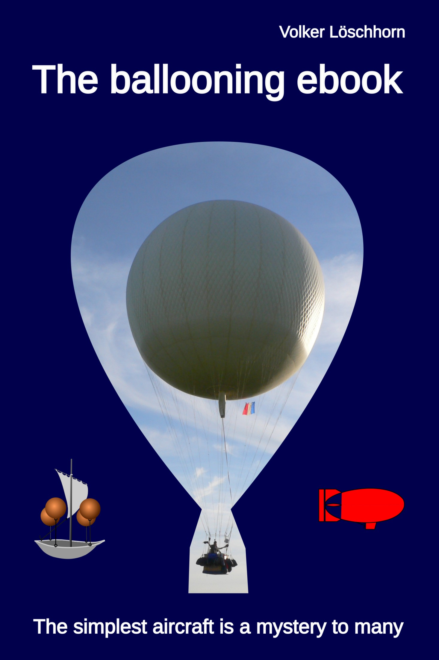The ballooning ebook cover
Humans conquered the skies with balloons. But there is something mysterious about balloons: are they really just toys of the wind, or can they be steered? Not directly, but indirectly by exploiting different wind currents. Modern wind forecasting techniques complement the pilot's intuition. A balloonist needs a deep understanding of the atmosphere and the laws governing the processes that take place within it. The troposphere is their playground. Balloon flight has many facets: commercial passenger transport for tourist purposes, advertising, leisure activities and sporting competitions. Almost everyone has seen a hot air balloon, but the much rarer gas balloons are hardly noticed. Yet they have been ruling the skies alongside birds for almost two centuries. And they are the longest-lasting mass-produced aircraft: they can stay in the air for over a hundred hours without landing. Such flights differ from ocean-going voyages in the same way that inland waterway transport differs from coastal shipping. This ballooning eBook aims to explain how it all works and how it is done. The author of the book, Volker Löschhorn, is himself an active balloon pilot and flight instructor. He is also active in the sport and has been German champion in gas ballooning several times. Here he shares his extensive experience mainly in text form, supplemented with a few illustrations. The book is aimed at those who are curious about balloon flights. But even experienced balloonists can discover something new – I promise!

About me
I started ballooning at the age of 10 in a youth camp run by the Stuttgart Ballooning Club. Many years have passed since then, during which I have experienced a lot in a balloon and gained a wealth of experience. Not every experience is one I would like to repeat, but there is hardly one I would want to miss.

Buy it here
www.epubli.com
It is available on all major platforms. Search for the title or ISBN: 9783819746192

Reading sample

Foreword
When did the first human being look after a bird and wish he could do the same and take to the skies? We don't know, and that it took many thousands of years for the first humans to leave the ground and take to the air. It is interesting to note that they did not imitate the flight of birds and did not take to the air with the help of aerodynamics, but ascended with the help of static lift. This is the greater intellectual achievement as no natural model was imitated, but aerodynamic flight was obviously technically more difficult to implement. Although Archimedes of Syracuse discovered and described the principle of hydrostatic lift in the 3rd century BC, more than two millennia ago, he did not apply it to the air. In 1650, Otto von Guericke had the idea that Archimedes' principle could also be applied to gases and gas mixtures such as air. He developed the dasymeter, which could be used to determine the buoyancy of a body in the air.
However, he was not thinking about airship travel, but he did inspire Francesco Lana de Terzi, who designed an airship in 1670 that gained its lift with vacuum spheres.
Vacuum is ideal for generating lift, but unfortunately to this day vacuum containers have to be built so heavy that they are heavier than the lift they generate, making them unsuitable for taking to the skies. There are various legends about fire-breathing figures and similar bodies that have risen into the air. The best evidence is that Bartolomeu Lourenco de Gusmão launched a small balloon at the Portuguese court in Lisbon in 1709. But it was the Montgolfier brothers' experiments in 1783 that set the development in motion. Yet despite this long history of balloon flight, ballooning remains a mystery to many: the fact that you can rise upwards with warm air or a light gas is generally accepted. But what happens next? How do you steer a balloon? Why are there balloons with sandbags and those without? And why do balloons no longer have an anchor? Balloonists are asked these and many other questions. In this book, I would like to answer these questions and explain how ballooning works.

Balloons
Ballooning today is done with three different classes of balloons, you could also say balloon types: Hot air balloons, gas balloons and Rozières (Mixed balloons). There are over ten thousand hot-air balloons worldwide, around half a hundred gas balloons and single-digit Rozières. Why one class of balloons is so common and the others so rare is revealed in the introduction to the individual balloon types.

Hot air balloon
The hot air balloon was the first balloon in the sky - its buoyancy is simply generated with hot air. In 1783, the brothers Étienne and Joseph Montgolfier launched the first hot-air balloon in front of an audience in the small town of Annonay in the south of France. As simple as the principle of generating hot air with fire was, the associated fire hazard was problematic: there were no non-combustible materials available for the envelope - the Montgolfiers built their balloons out of canvas coated with handmade paper - nor was heating with solid fuels such as straw practical. The hot-air balloon therefore led a shadowy existence for almost two centuries until the materials and fuel for the modern hot-air balloon became available in the 1960s: Plastic fibers for the envelope, and propane as an easy-to-handle fuel. Incidentally, hot-air balloons are often referred to as Montgolfières after their inventors.

Hot-air airships
Hot-air airships are hot-air balloons, also known as guided balloons. They consist of a balloon envelope that is aerodynamically shaped for horizontal movement against the air. They have a rudder and a drive with a propeller. As with a hot-air balloon, the height is generated by heating the air in the balloon envelope to varying degrees. In some hot-air airships, a slight overpressure is generated in the envelope with the help of a fan, which stabilizes the envelope and enables higher speeds. The operation of a hot-air airship requires many helpers and is therefore time-consuming. There have been championships, including world championships, but these do not take place regularly. Most of the time, the few hot-air airships are used for promotional purposes.

Gas balloon
The invention of the gas balloon was a commissioned work. News of the balloon's ascent in Annonay spread like wildfire to Paris, where people also wanted to see a balloon rise. The scientist Professor Charles was commissioned to carry out the project. He had heard that the Montgolfiers had invented a new gas. He suspected that it was the lightest of all gases - hydrogen. Together with the Robert brothers, he built a gas-tight envelope and a hydrogen generator, and just two weeks after the first Montgolfière ascended, the first gas balloon was launched in Paris - the Charlière. Once filled with gas, a gas balloon should be able to fly indefinitely - provided the envelope is tight - as it does not need to be constantly reheated to maintain buoyancy as a hot air balloon does. This would also work if it weren't for the sun. This heats up the lifting gas during the day, and at night it cools down and contracts, and the balloon loses volume and therefore buoyancy. This loss of buoyancy is compensated for by jettisoning some of the ballast carried for this purpose. This cannot be done as often as required, but under favorable conditions a modern gas balloon could be used for three to five days without landing in between. Today, hydrogen is generally used as the lifting gas for gas balloons. The only negative property of hydrogen gas for use in balloons is that it is flammable. To prevent the hydrogen gas from igniting due to electrostatic charging, the envelopes have a conductive coating so that no charge differences sufficient for ignition sparks can form. The non-flammable but twice as heavy and very expensive noble gas helium is rarely used. Unfortunately, neither hydrogen nor helium or other suitable gases are available everywhere, and transportation is complex and therefore expensive. Hydrogen can only be obtained cheaply at launch sites that are supplied by a pipeline. Unfortunately, these launch sites are very rare; there are five in Germany and none abroad.

Gas balloon launchsites
Here are the launch sites in Germany that provide hydrogen either via a pipeline or a stationary tank:
Düsseldorf: https://www.ballon-duesseldorf.de/
Gladbeck: http://www.ballon.org/
Münster: https://www.fsv-muensterland.de/
Ibbenbüren: http://www.ballonclub-teuto.de/
Bitterfeld-Wolfen: https://www.ballon-bitterfeld.de
Burgkirchen: https://freiballonclub-salzach-inn.chayns.site/
Gersthofen: https://www.augsburg-ballon.de/
Stuttgart: https://ballonsportgruppe-stuttgart.de/

Rozière
Is there an advantage to combining gas and hot air balloons? Pilâtre de Rozier asked himself this question and built a combination of the two, the Rozière, named after him. He used it to attempt to cross the Channel to England on June 15, 1785. Unfortunately, he had neither the incombustible lifting gas helium nor incombustible materials for the envelope. Even heating the hot air envelope under the hydrogen envelope with straw was not possible without flying sparks. The cause could not be determined, but the … Read more in the ebook.

Content
- Foreword
- Balloons
  - Hot air balloon
    - Hot-air airships
  - Gas balloon
    - Gas balloon launchsites
  - Rozière
  - Model balloons
  - Other types of balloons
  - Pilots
    - Prerequisites
    - Training
    - Examination
    - Further qualifications
    - Training according to EASA rules
    - UL balloon pilots
  - Balloon team
    - Chaser
    - Competition officials
    - Technician
  - Balloon flight
  - Weather
  - Here we go
  - Rigging
  - Start
  - Flight
  - Chaser
  - Landing
- Theory - what the balloonist should know
  - Aerostatics
  - Buoyancy, lifting capacity and payload
- Balloon technology
- Know - feel - act intuitively
- On-board instruments
- Balloon weather
- Ballooning - sport?!
  - Hot air balloon competitions
  - Gas balloon competitions
  - Special challenges of long flights
  - Procedure of a large gas balloon flight
- Environement
- Security

