Association in the death zone
How did the club get there - and above all, how will it get out?
A club in the DEATH ZONE. But what is the death zone anyway? The term comes from mountaineering and describes the altitude range at which complete regeneration is no longer possible - because the body can no longer absorb enough oxygen. Applied to our association, the death zone means that it is shrinking because we are no longer gaining enough new members. And that if we don't reverse this process, it will mean the end of the club in the long term. The book Association in the death zone is about the mechanisms that can lead a club into the death zone and, above all, how to get out of it. I hope you enjoy reading it!
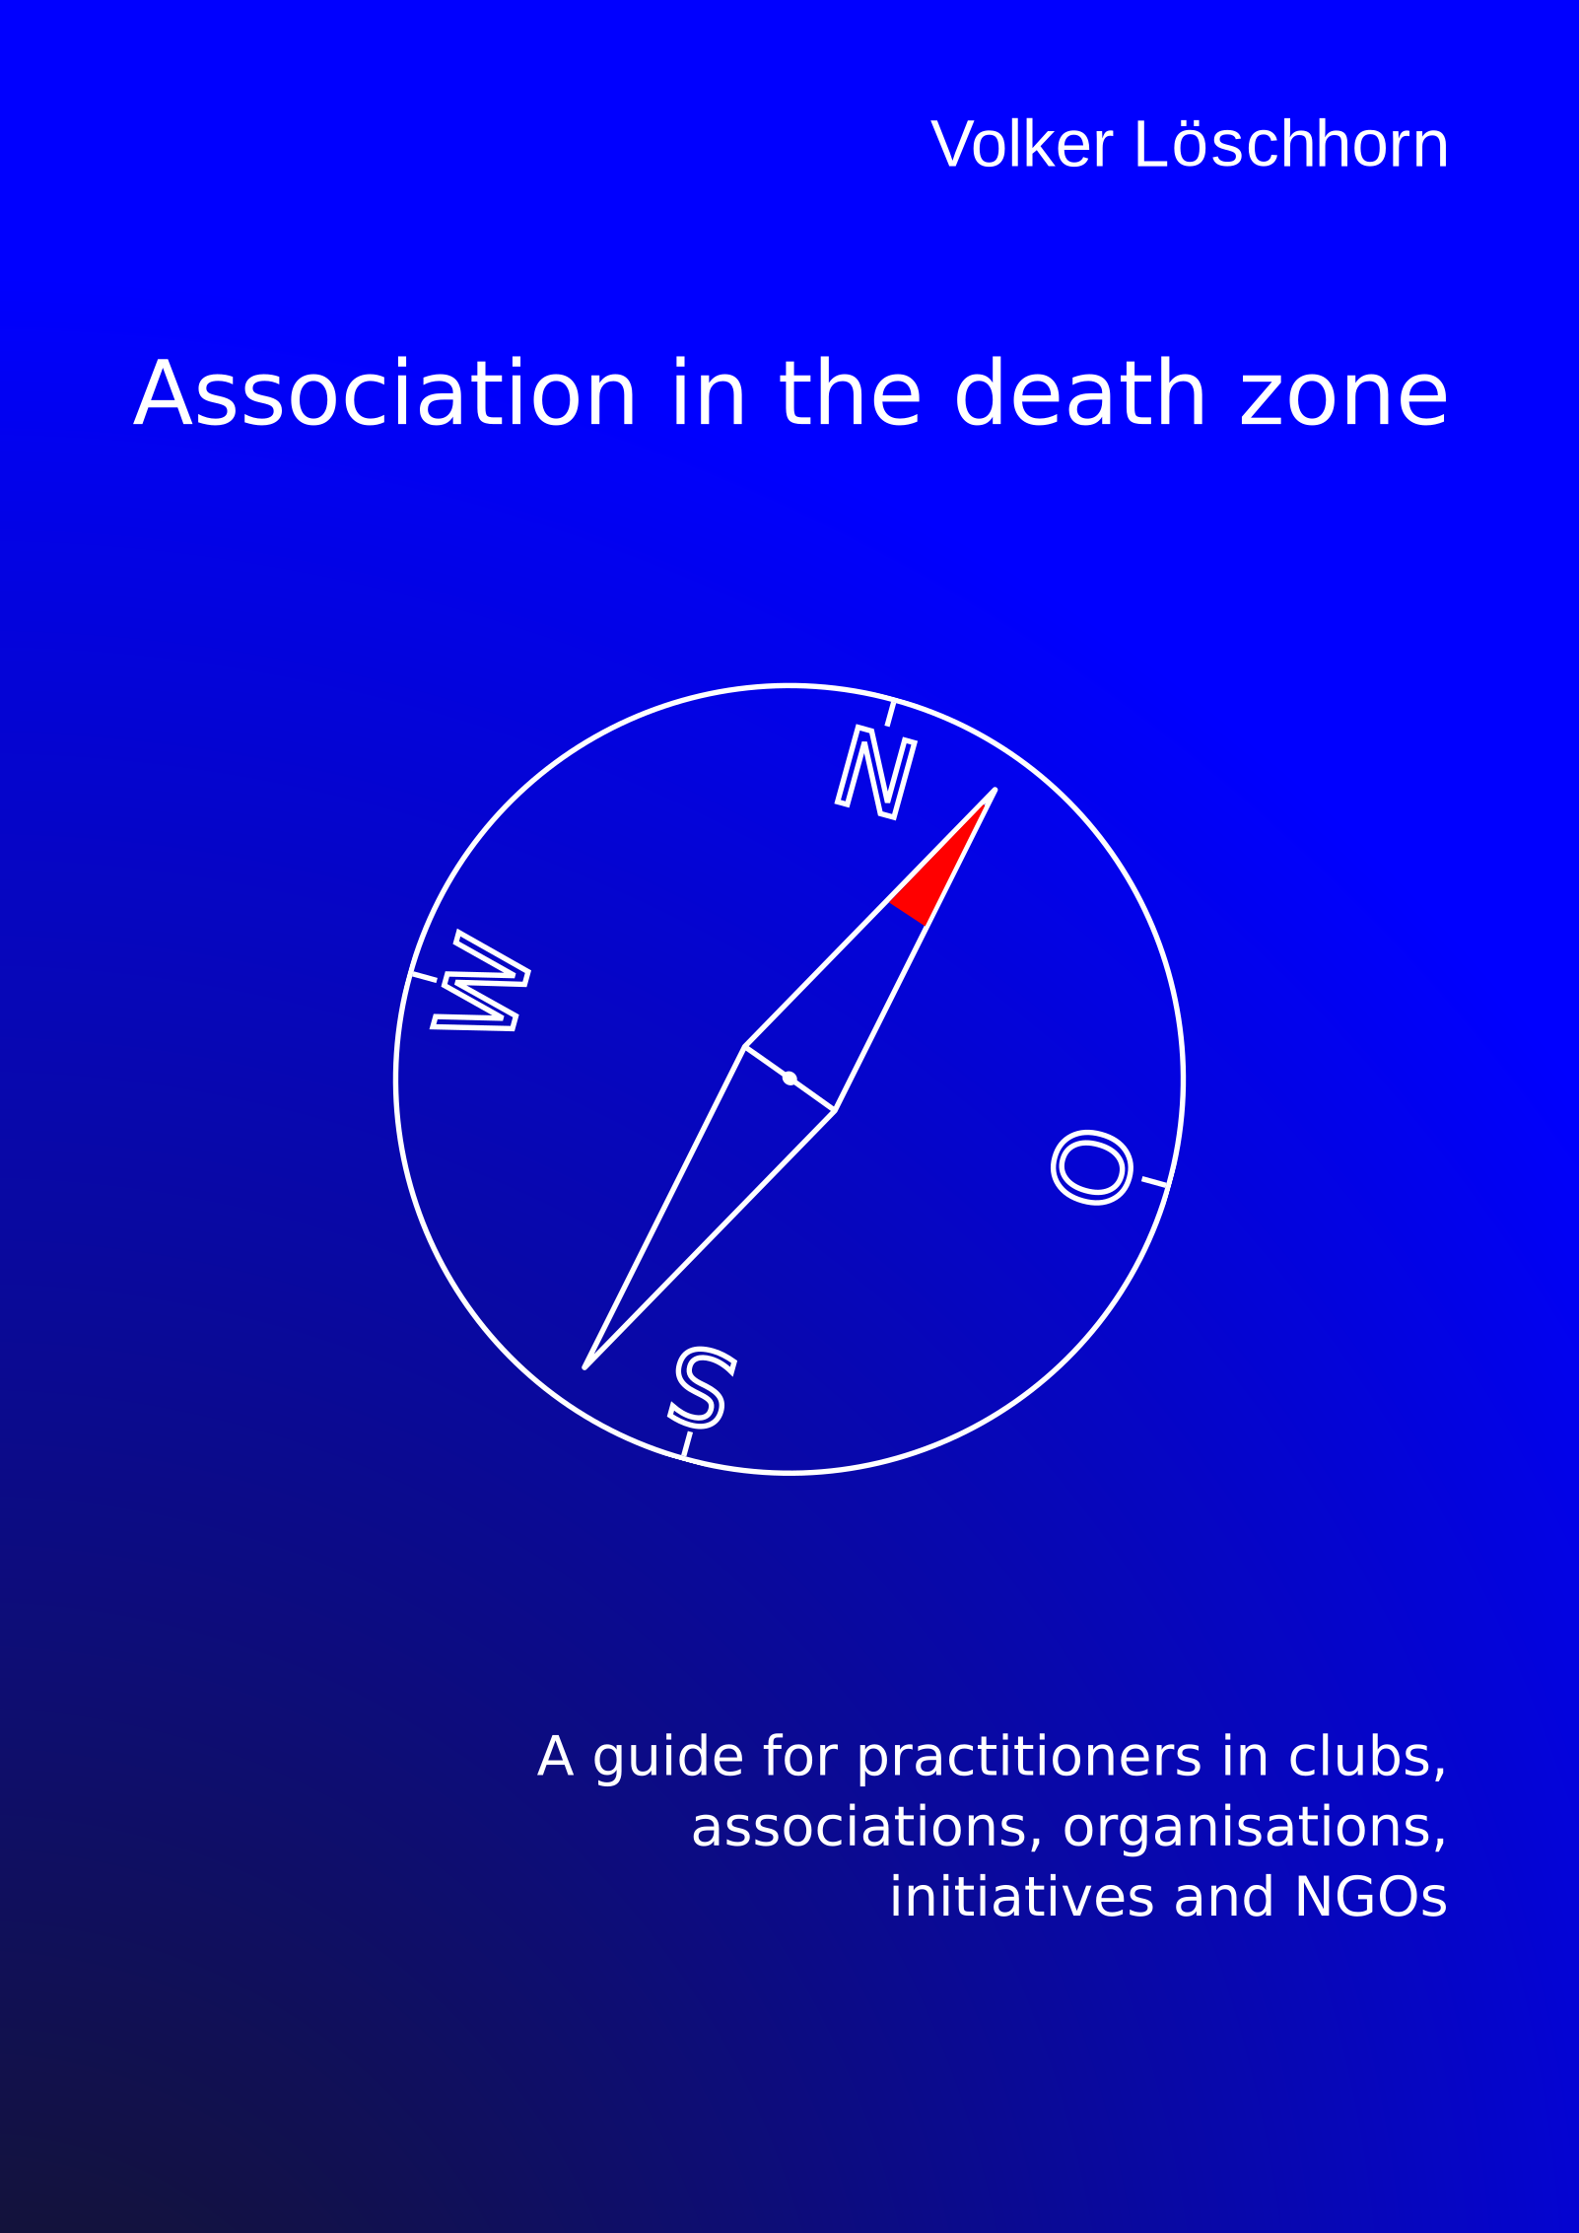Cover of the book Association in the death zone
The book is published by epubli and can be purchased here: eBook»epubli.com

